- Vacina adsorvida covid-19 (inativada) – Sinovac / Instituto Butantan

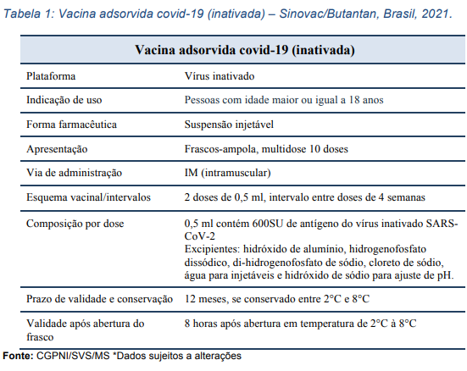

Vacina covid-19 (recombinante) – AstraZeneca/Fiocruz

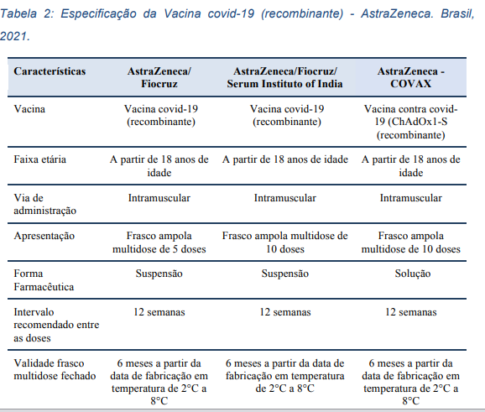
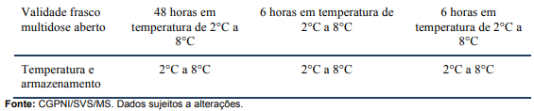

Vacina covid-19 (RNAm) (Comirnaty) – Pfizer/Wyeth

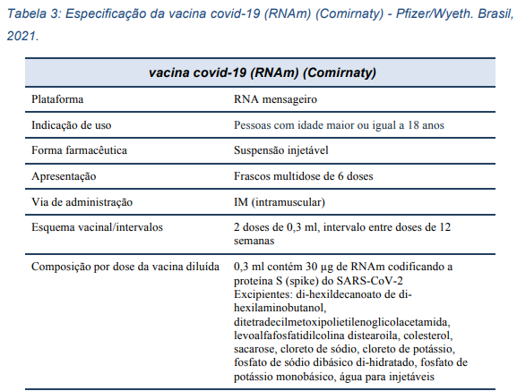
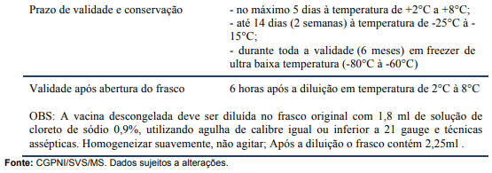

Vacina covid-19 (recombinante) – Janssen

